Economic Development as Global Learning /  Linking the Structure to the Dynamics of Collective Learning

Andres Gomez-Lievano

Michele Coscia

Old quantitative theories of societal evolution originally highlighted the nontrivial pattern of nestedness  The process of accumulating and coordinating increasingly complex productive capabilities, resulting in economic development, has been well documented in many empirical studies and has been the basis for the Theory of Economic Complexity. In order to quantify the size of the body of collective know-how an economy has accumulated, the index of economic complexity was developed some years ago. Some controversies surrounding this index have emerged, and some confusion has surrounded the meaning of the index. Here we provide a clarification of its meaning, why it works, and what it means for how economic development unfolds in the world.

# Introduction

For more than a century the field of anthropology has known that human societies, while highly dynamic, diverse, and idiosyncratic, change diachronically through a series of stages of “complexification” (Carneiro 1970; Carneiro 1962). This particular way of cultural unfolding is the result of two processes: one is the diffusion and transmission of cultural traits across human groups and across generations, while the other is the development (through chance or insight) of more complex traits, which is conditionally enabled by previous developments of less complex traits. The question of whether modern countries, regions and cities develop through the same processes has not been fully studied and analyzed. Here we develop an analytical framework to analyze such processes, and we present strong evidence that they still stand as the fundamental workings of today’s modern societies.

The first piece of evidence that the same processes that have shaped cultural evolution for thousands of years are still driving current economic development comes from the nestedness of technological matrices (Fig. ???)

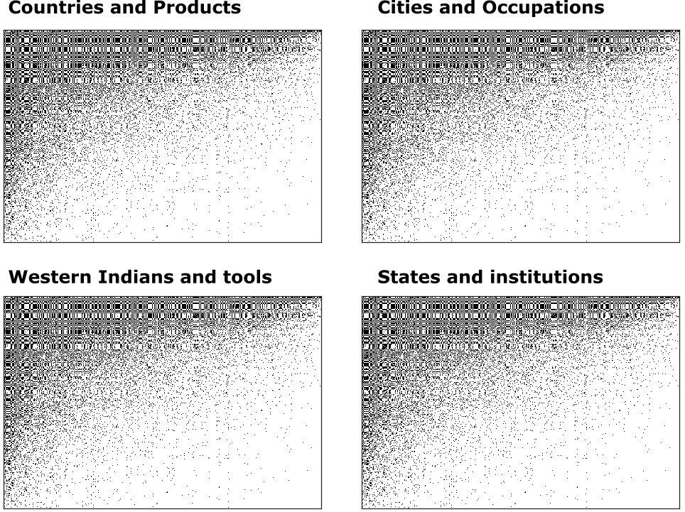

[I THINK WE SHOULD START WITH A FIGURE SHOWING THE PATTERN OF NESTEDNESS (OR LACK THEREOF) IN DIFFERENT TYPES OF ASSOCIATIONS, DIFFERENT CONTEXTS, DIFFERENT SCALES, AND DIFFERENT TIMES]

Among the many theories of socioeconomic evolution, one that has recently gained attention is the Theory of Economic Complexity (TEC) (Hausmann and Klinger 2006; Hidalgo et al. 2007; Arthur, n.d.; Arthur and Polak 2006; Hausmann and Hidalgo 2010; Bahar, Hausmann, and Hidalgo 2012; Frenken and Boschma, n.d.). TEC emphasizes the flows of tacit know-how as opposed to the flows of ideas, capital or labor. Importantly, TEC emphasizes the combinatorial quality in which qualitatively different pieces of know-how can complement each other, instead of the emphasis traditionally given to knowledge spillovers and the unstructured flows of ideas (Lucas 2008). The main take-away from TEC is that societal development is the process of both accumulating, coordinating, and successfully deploying, qualitatively different pieces of productive know-how.

TEC has already proven to be a unifying paradigm. It explains why rich countries are diverse while poor countries are not (Hausmann and Hidalgo 2011; Hidalgo and Hausmann 2009), which itself suggests that economic development is process of diversification, not specialization. TEC also suggests an explanation for the phenomenon of urban scaling, whereby larger cities are disproportionately more productive (Gomez-Lievano, Patterson-Lomba, and Hausmann 2016; Neffke 2017), and it explains and predicts how do regions (cities, regions or countries) diversify over time (Neffke and Henning 2012; Neffke, Henning, and Boschma 2011; Neffke, Henning, and Boschma 2011; Hidalgo et al. 2007; Cristelli, Tacchella, and Pietronero 2015; Cristelli, Tacchella, and Pietronero 2014). Central to this paradigm is the question of *how much does a team of individuals know?* In other words, it pushes the research agenda towards the task of quantifying *collective know-how*, and tracking the way it grows, contracts, and is transmitted from society to society and from generation to generation (Richerson and Boyd 2004; Henrich 2016).

The notion of collective know-how has to be distinguished from the notion of human capital. Human capital, as it has been used in the literature (Romer 1989; Romer 1989; Jones and Romer 2009) is an individual-specific property. In contrast, collective know-how is a group-specific property. Societies may or may not have individuals with high human capital, but still have high collective know-how. That is, a collective of individuals that know is different from a collective that knows. In an extended interpretation, collective know-how can be seen as the body of culture, as is defined in the field of Cultural Evolution (Feldman and Cavalli-Sforza 1986; Cavalli-Sforza et al. 1982; Feldman and Cavalli-Sforza 1984; Richerson and Boyd 2008; Badcock, Boyd, and Richerson 1988; Boyd, Richerson, and Henrich 2013; Griesemer, Boyd, and Richerson 1986; Richerson and Boyd 2004; Henrich 2016; Muthukrishna and Henrich 2016; Muthukrishna et al. 2017). In this field, the term “cultural accumulation” is precisely the process of expanding a society’s body of collective know-how. In other words, cultural accumulation is the process of collective learning.

The field of cultural evolution has shown the difficulty of formalizing the notion of collective know-how. Hence, there many ongoing efforts about measuring the collective know-how of groups of individuals (Mesoudi 2017; Kempe, Lycett, and Mesoudi 2014; Legare 2017; Kline and Boyd 2010; Vaesen 2012; Henrich 2004). Conceptually, it is even difficult to define what know-how is. In the literature of cultural evolution, the amount of culture (i.e., the size of a society’s collective know-how) is proxied by the number of cultural elements (e.g., the number of technologies and tools in the cultural repertoir). Similarly, one good proxy for the collective know-how of a country is the number of products it exports to the world. Hence, it is reasonable to define know-how as “the size of all the different things the society knows how to do”, analogously to how we assess students knowledge in standardized tests. However, knowing how to do difficult things counts more than know how to do simple things. Hence, in the reference (Hidalgo and Hausmann 2009) an attempt was made to derive a measure of collective know-how, and thus the Economic Complexity Index, or ECI, was born.

In this paper we introduce a new way of understanding how collective know-how expands, is maintained or lost, and we take the opportunity to clarify confusions and controversies surrounding the Economic Complexity Index (Hausmann and Hidalgo 2011; Hidalgo and Hausmann 2009), which was expressed mathematically in its current form in the reference (Hausmann et al. 2011).

# Collective learning by imitation

Societies evolve in a multidimensional space [Brummitt et al. 2018?]. They change their position in this space as they acquire or lose capabilities, such that each dimension is a capability. Societies that are complex and developed will occupy many dimensions, while less complex societies will occupy few dimensions. We postulate that the dynamical laws in this space arise from societies trying to copy the most complex societies.

# Imitation leads to a single community, combinatorics leads to nestedness

The theoretical hypothesis presented before leads to the prediction that the world should display a nested structure. This structure is captured by the left-eigenvector a matrix which is the projection of the technological matrix, into how much technological overlap there is between societies.

# Mathematical Definition of ECI and Properties

The calculation of the ECI starts from the matrix of countries (rows) and the products (columns) they export, $M$. Let this matrix have size $C×P$. This is a matrix that has been discretized so that $M_{c,p}$ is 1 if the product $p$ is exported in country $c$, and 0 otherwise. From this matrix, one creates two stochastic matrices. First, the right-stochastic (i.e., row-stochastic or row-normalized) transition matrix of “countries to products”,

$$R=diag\left(1/d\right)⋅M,$$

and second, the left-stochastic (i.e., column-stochastic or column-normalized) transition matrix of “products to countries”,

$$L=M⋅diag\left(1/u\right),$$

where $d=M⋅1$ is the vector that contains the number of products a country exports (i.e., its *diversity*) and where $u=M^{T}⋅1$ is the vector that contains the number of countries from which the product is exported (i.e., its *ubiquity*). We use the notation $diag\left(x\right)$ to mean the matrix whose diagonal is the vector $x$ and the other values are zero, and $1$ to denote a vector of 1’s.

Four important characteristics of left-stochastic matrices are worth mentioning, as they will be useful below:[1]

1. A stochastic matrix for discrete markov chain can be represented as a network of nodes connected through directed edges.
2. Multiplying on the right of the matrix is the way of *propagating probabilities* through the network of connected nodes.
3. Multiplying on the left of the matrix is the way of *averaging some node-specific property* conditioned on standing on each of the nodes and only observing the nodes to which probabilities propagate to.

Let us construct the left-stochastic transition probability matrix of “countries to countries” (Yildirim and Coscia 2014),

$$C=L⋅R^{T}.$$

For mathematical convenience, we will assume that the stochastic matrix $C$ is irreducible and aperiodic.[2]

Now, let ${l_{i}}^{T}$ and $r_{i}$ be the $i$ th left-eigenvector and right-eigenvector, respectively, so that the eigenvalues are ordered in decreasing value, $λ_{1}≥λ_{2}≥⋯≥λ_{C}$. The list of ECIs for countries is defined as the left sub-dominant eigenvector, ${ECI}^{T}≡{l_{2}}^{T}$:

$$\begin{matrix}{ECI}^{T}⋅C=λ_{2}{ECI}^{T}.\end{matrix}$$

It is easy to prove that the vector $d$ of the diversity of countries is orthogonal to the vector of ECIs, $ECI$, once you realize that $d$ is actually the dominant right-eigenvector (sometimes referred to as the “perron” eigenvector, or just simply, the stationary distribution of the discrete markov chain defined by $C$). Thus, multiplying $d$ on the right of $C$, and expanding $C$ into its components,

$$\begin{matrix}C⋅d & =(L⋅R^{T})⋅d, \\ & =(M⋅diag\left(1/u\right))⋅(diag\left(1/d\right)⋅M)^{T}⋅d, \\ & =(M⋅diag\left(1/u\right))⋅(M^{T}diag\left(1/d\right))⋅d, \\ & =(M⋅diag\left(1/u\right))⋅M^{T}⋅1, \\ & =(M⋅diag\left(1/u\right))⋅u, \\ & =M⋅1, \\ & =d.\end{matrix}$$

Thus, $d$ is a right-eigenvector of $C$ associated with the eigenvalue $λ_{1}=1$, which from the Perron-Frobenius theorem one concludes that $d$ is the *dominant* right-eigenvector. This means, given classical results from discrete markov chains, that the stationary distribution of the stochastic process defined by $C$ is ${\boldsymbol \pi} = {\mathbf{d}}/\sum_c d_c$. Therefore, since left-eigenvectors are orthogonal to right-eigenvectors, ${l_{i}}^{T}⋅r_{j}=δ_{i,j}$ (assuming eigenvectors have norm one), we conclude that

$${ECI}^{T}⋅d=0,$$

which is a result that had been noted before already in reference (Kemp-Benedict 2014).

All these results apply to the product space matrix as well, $P=R^{T}⋅L$. Namely, the sub-dominant left-eigenvector is the list of product complexity indices, PCIs, and the dominant right-eigenvector is proportional to the list of ubiquities.

One of the ways the economic complexity index has been defined is by postulating that products have a complexity, and that the complexity of countries is the average complexity of the products it exports. Conversely, one defines the complexity of the products as the average complexity of the countries where it is exported. It is claimed that this uniquely defines these two vectors. This is true, although any of the left-eigenvectors of the matrices $C$ and $P$ have this precise property. To show it, recall that ${l_{i}}^{T}$ and $r_{i}$ are the $i$ th left-eigenvector and right-eigenvector of $C$, respectively, and assume denote now ${q_{i}}^{T}$ and $s_{i}$ be the $i$ th left-eigenvector and right-eigenvector, respectively, of $P$. First, note that

$$\begin{matrix}C⋅L & =\left(LR^{T}\right)⋅L, \\ & =L⋅\left(R^{T}L\right), \\ & =L⋅P.\end{matrix}$$

And second, start from the fact that $λ_{i}{l_{i}}^{T}={l_{i}}^{T}⋅C$, and multiply it on the right by the matrix $L$, and then use Eq. (???):

$$\begin{matrix}\left(λ_{i}{l_{i}}^{T}\right)⋅L & =\left({l_{i}}^{T}⋅C\right)⋅L, \\ λ_{i}\left({l_{i}}^{T}⋅L\right) & ={l_{i}}^{T}⋅\left(C⋅L\right), \\ & ={l_{i}}^{T}⋅\left(L⋅P\right), \\ & =\left({l_{i}}^{T}⋅L\right)⋅P,\end{matrix}$$

which can be re-written as

$$\begin{matrix}λ_{i}{q_{i}}^{T} & ={q_{i}}^{T}⋅P.\end{matrix}$$

It is easy to see from Equations (???) and (???) that if ${l_{i}}^{T}$ is a left-eigenvector of $C$, then the vector ${l_{i}}^{T}⋅L$ is the $i$ th left-eigenvector of $P$, such that ${q_{i}}^{T}={l_{i}}^{T}⋅L$. Since multiplying on the left of a left-stochastic matrix takes averages, we see that the left-eigenvectors of the product space are the averages of the left-eigenvectors of the country space. In particular, for the complexity indices. Furthermore, we obtain that the eigenvalues of both matrices are the same.[3] This result, obviously, applies to the sub-dominant eigenvectors of both matrices, which are the complexity indices. But the point is that if we use the definition of complexities based on the averages, one has to choose among $min\{C,P\}$ choices.

Now, the values of ECI have been shown to be positively associated with income levels and income growth of countries (Hidalgo and Hausmann 2009). However, a clear and direct interpretation of the physical meaning of ECI, as the sub-dominant left-eigenvector, and its association with a measure of collective know-how, and its link to economic growth, has been lacking. The reason for this confusion is born out, first, from its flawed interpretation as a linear measure to rank countries, and second, as that interpretation that states that it is that quantity which is the average property of products.

In the next section, we clarify these issues, and we show why it is that ECI is, in fact, a good indicator of the size of the collective know-how of countries. The argument is, however, both obvious and non-trivial. Obvious precisely because of its interpretation as the sub-dominant left-eigenvector, but non-trivial, from the ultimate significance about the emphasis it gives to the underlying process of economic development as a process of collective learning.

# Left is for communities, right for capabilities [IS THERE A GAME OF WORDS HERE, THAT MAY HAVE BEEN USED IN THE CONTEXT OF (left, communist) AND (right, capitalist)?]

The ECI is an index that separates the set of countries in two communities, a core and a periphery. Mathematically, we show that it maximizes a community discovery task. Numerically, we create a synthetic world of several communities, and show that $ECI$ is the answer to the question *which of two communities does each country belong to?* Finally, we will show that the role of the ECI becomes evident when we use the flattened export vs. product-importer matrix.

The takeaway from this section is more general, though. We show both left-eigenvectors and right-eigenvectors contain the information about the community structure of the network. However, left-eigenvectors are better about the statistical identification of communities, while the right-eigenvectors are better about measuring capabilities. These two realms are related since the extent to which a country is embedded in a community is itself a measure of the number of capabilities it has. The ultimate reason is Anna Karenina’s Principle. Richly diversified countries tend to be all alike, while poorly diversified countries are poorly diversified in their own way.

## Numerical demonstration

Recalling that $C$ is a left-stochastic matrix, there are several known results about its spectral properties and their relation to community structure (Capocci et al. 2005; Malliaros and Vazirgiannis 2013).

First, if the nodes of the network are organized in well-defined $k$ clusters, then there are $k−1$ relatively large, nontrivial, eigenvalues, in addition to the dominant eigenvalue with value equal to 1 (Chauhan, Girvan, and Ott 2009). Thus, a heuristic that can be used to infer the number of communities in a network is to count the number of eigenvalues larger than, say, 0.1, in the spectrum of the stochastic matrix. Second, the eigenvectors (both left- and right-eigenvectors) associated with those $k−1$ nontrivial eigenvalues reveal the structure of the clusters. Hence, if the clusters are well-defined, carrying out a $k$-means clustering on the matrix $E_{C×k−1}$ where the columns are the $k−1$ left-eigenvectors of $C$ would identify the $k$ clusters.

In our case, the left-eigenvectors of $C$ can be used to discover the communities of countries, where the communities are the based on how similar are the export baskets of countries. But as we will show, both left and right-eigenvectors can carry out this function.

As a comparison, we create three $M$ matrices. The first, we created by putting $M_{c,p}=1$ with a probability of 0.6 if $c$ and $p$ belong to the same community, and with probability 0.1 if they belong to different ones. The second way is following (Hidalgo and Hausmann 2009; Hausmann and Hidalgo 2011), who hypothesize the interaction between two matrices, ${\mathbf{ {\mathcal C}}}$ and ${\mathbf{ {\mathcal P}}}$ determines $M$. These underlying matrices are also binary matrices, which can be thought of as the matrix of countries and the capabilities they have on the one hand, and the matrix of products and the capabilities they require to be produced on the other, such that ${\mathbf{ M}}={\mathbf{ {\mathcal C}}} \odot {\mathbf{ {\mathcal P}}}$, where the operator $⊙$ is a production function operator, which we choose as the Leontief (i.e., a country produces a product if it has all the capabilities required to produce it). Finally, the third way to construct $M$ is from real data. We choose the year 2015, 224 countries and 773 products (SITC4 codes).

Figure ??? shows the results from the matrix filled uniformly, with five communities. Figure ???  shows the results from the matrix created based on an underlying structure of capabilities, with also five communities. Figure ??? show the results from real data.

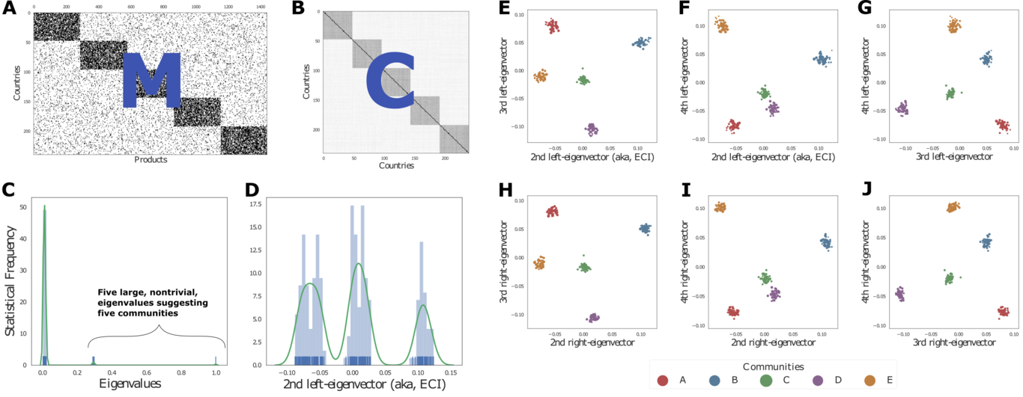

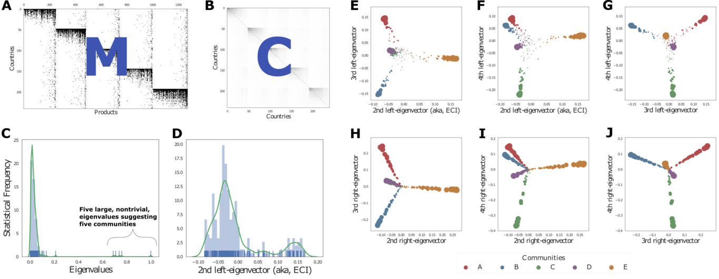

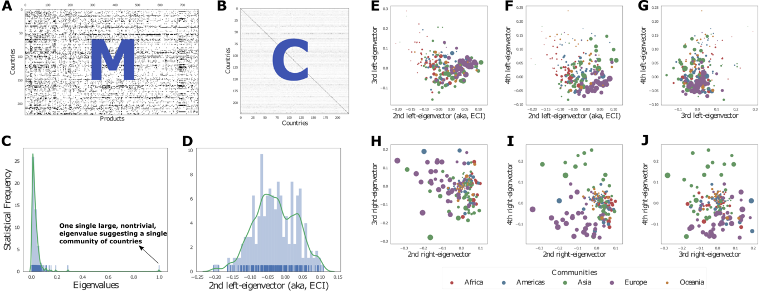

As can be seen from Fig. 1 and Fig. 2, the left and right eigenvectors of the matrix of the country space is helpful in identifying the communities. The

## Empirical demonstration (MICHELE’S SECTION)

Given the literal interpretation that ECI has received as a physical measure of know-how, and its success predicting economic growth, it would seem hard to demonstrate that ECI is a clustering index. However, we can use a trick in order to disentangle the economic component of the ECI from its community-related properties. The goal is to try to use ECI to reveal *geographical communities*, which is accomplished when we add a *geographical dimension* to the matrix $M$: the geographical region of destination where the exporter is exporting a product, i.e, the importer. Hence, we will now have a tensor, $M_{c,i,p}$, where $c$ is the index of the exporter country, $i$ the importer, and $p$ the product traded.

## Mathematical demonstration

Let us begin by showing that $ECI$ is a solution to the following optimization problem:

$$\begin{matrix}max\sum_{c′}{\frac{1}{d_{c′}}}\sum_{c,p}{\left(\frac{1_{(c∧c′ export p)}}{u_{p}}\right)}1_{(c∧c′ same community)}\end{matrix}$$

The free parameters of the maximization are the assignments of countries to one of *two communities*. Let us list the properties of this quantity:

* It is higher if countries $c$ and $c′$ export products of low ubiquity (i.e., products that are rare, or difficult to produce).
* It is higher if country $c′$ exports few products.
* It is higher if countries $c$ and $c′$ export the same products.
* It is higher if countries $c$ and $c′$ belong to the same community.

Since the only moving part in the quantity is to which of the communities countries belong to, the algorithm will put countries that export the same products together. Furthermore, the algorithm will weigh much more when countries export rare, and presumably difficult to make, products. Finally, each country contributes to the quantity, and since you don’t want diverse countries to dominate the sum, you divide by each country’s diversity. [THE ARGUMENT THAT i’D LIKE TO DEVELOP FURTHER IS THAT WHAT THE PREVIOUS PARAGRAPH IS DESCRIBING NOT ONLY THE DEFINITION OF THE ECI; iT IS THE STATE VARIABLE THAT AN ECONOMY IS TRYING TO MAXIMIZE IN THE REAL WORLD. THAT IS, COUNTRIES ARE NOT TRYING TO MAXIMIZE gdp, THEY’RE REALLY (BUT UNCONSCIOUSLY AND IMPLICITLY) TRYING TO MAXIMIZE eci. hENCE, AN ECONOMY IS TRYING TO BELONG TO A COMMUNITY. THIS SHOULD SHELD LIGHT TO DIFFERENT ASPECTS OF THE DIVERSIFICATION PROCESS, AND THUS, IT SHOULD REVEAL THE “DENSITY REGRESSIONS”.]

Let us define the vector $s$, such that $s_{c}=−1$ if the country $c$ belongs to community 1, and $s_{c}=1$ if $c$ belongs to community 2. Recalling the definition of the elements $M_{c,p}$ of the matrix $M$, the quantity to maximize in Eq. (???) can be written as

$$\begin{matrix}Q & =\sum_{c′,c,p}{\left(\frac{1_{(c∧c′ export p)}}{u_{p}}\frac{1}{d_{c′}}\right)}1_{(c∧c′ same community)}, \\ & =\sum_{c′,c,p}{\left(\frac{M_{c,p}M_{c′,p}}{u_{p}d_{c′}}\right)}\left(\frac{s_{c}s_{c′}+1}{2}\right), \\ & ∝\sum_{c′,c,p}{s_{c}}\left(\frac{M_{c,p}M_{c′,p}}{u_{p}d_{c′}}\right)s_{c′}, \\ & =s^{T}\left(M⋅diag\left(1/u\right))⋅(M^{T}diag\left(1/d\right)\right)s, \\ & =s^{T}Cs.\end{matrix}$$

Therefore, the problem is how to choose $s$ so as to maximize the expression in Equation (???). The strategy for solving this problem is the so-called “spectral approach” (Malliaros and Vazirgiannis 2013; Newman 2006), expressing the vector $s^{T}$ as a linear combination of the eigenvectors of $C$. Directly replacing this into Eq. (???) will not be useful because the eigenvectors of a non-symmetric matrix are not orthogonal among themselves (only to the other side eigenvectors counterparts). So let us express $s$ using both the left and right-eigenvectors,

$$\begin{matrix}s^{T} & =\sum_{i}{a_{i}}{l_{i}}^{T}, \\ s & =\sum_{i}{b_{i}}r_{i}.\end{matrix}$$

Replacing these expressions in Eq. (???), we get

$$\begin{matrix}Q & =\sum_{i}{λ_{i}}a_{i}b_{i}.\end{matrix}$$

As has been shown in a number of different instances (Newman and Girvan 2004; Leicht and Newman 2008; Newman 2006), this quantity can be maximized by choosing the $s$ to be parallel to eigenvectors with the largest eigenvalues, subject to the constraint that $s^{T}⋅s=C$. In other words, since the maximization problem was originally set as to find the two main communities, one must choose the subdominant eigenvalue, and therefore the corresponding eigenvectors.

# Improvements on the Theory of Economic Complexity

The Theory of Economic Complexity introduced two main ideas to understand economic development. On the one hand, it proposed that economic development is growth at the extensive margin, or, in less technical terms, economic development is a process of diversification. On the other hand, it introduced the notion that economic development is a historical process, in the sense that the extensive margin is constrained by path dependence and therefore its growth depends on previous contingent events.

These conceptual innovations were accompanied by two analytical tools: the technological space that gives structure to the historical process of development, and the quantification of how much a society knows as a collective through an index of economic complexity. Here we show how our understanding of the physical and mathematical meaning of both innovations allow us to improve both notions. We demonstrate this by showing a superior capacity to predict growth.

Hypothesis 1:

A better algorithm to calculate the embeddedness of a country in a community may predict the appearance of specific products better than before.

Hypothesis 2:

A better measure (remember to make a difference between an index, and a measurement/inference) of economic complexity may predict GDP growth better than before.

# The significance of belonging to a community

The discovery presented in Section ??? that ECI is a community discovery index is very important piece to understand the process of economic development. In concise terms, it suggests that countries accumulate capabilities by “looking” like one another. They accomplish this by processes whereby local firms imitate foreign firms, by people migrating in and out of countries. This process drives the fact that there are no separate communities of countries, but only one. But what explains the fact that is nested?

Nestedness comes from the fact that the underlying matrix of capabilities that countries have, and the matrix of capabilities required by products, are *also* nested.

# Discussion

The results of this paper can be concisely summarized as follows: economic development is first and foremost a process of global imitation with local exploration. Imitation gives rise to a single connected network of countries, and both imitation and local exploration gives rise to the nested structure in which richer countries are more diverse and build on what less diverse countries know-how to do. The main significance of this is that humanity as a whole is exploring a single branch of the technological tree.

Methodologically, our results imply that identifying the community in the network to which an economy belongs provides a wealth of information about the current and future productive capabilities of the economy.

# Conclusion

The field of economics has improved of our understanding of markets. In markets, the two organizing concepts are price and quantity, and the main organizing mechanism is the equalization of supply and demand. The Theory of Economic Complexity complements our understanding of economic systems by emphasizing the role of collective know-how. The adaptability, welfare, and robustness of an economy all are determined by the size of the collective know-how of a society. While the traditional market-centered approach to economics has developed sophisticated tools to track the flows of value and money, TEC is in the process of developing better tools and formalisms to track the expansion, maintenance, and transference, of collective know-how. In this paper we have build on previous ideas to reinforce the claim that networks are behind the processes of economic development: networks highlight collective-level properties like communities. And the main questions are thus: how do economic communities are formed? Why do nodes in the same community grow together? Why do we see convergence in income when nodes belong to the same community (Coscia and Hausmann!)(Coscia and Cheston 2017; Coscia and Hausmann 2015)?

# Hello

*this is cursive and ghere is a citation (Hausmann, Pritchett, and Rodrik 2004)*

# References

Carneiro, Robert L. 1970. “A Quantitative Law in Anthropology”. *American Antiquity* 35 (04). Cambridge University Press (CUP): 492–94. doi:10.2307/278125.

———. 1962. “Scale Analysis as an Instrument for the Study of Cultural Evolution”. *Southwestern Journal of Anthropology* 18 (2). University of Chicago Press: 149–69. doi:10.1086/soutjanth.18.2.3629014.

Hausmann, Ricardo, and Bailey Klinger. 2006. “Structural Transformation and Patterns of Comparative Advantage in the Product Space”. *SSRN Electronic Journal*. Elsevier BV. doi:10.2139/ssrn.939646.

Hidalgo, C. A., B. Klinger, A.-L. Barabasi, and R. Hausmann. 2007. “The Product Space Conditions the Development of Nations”. *Science* 317 (5837). American Association for the Advancement of Science (AAAS): 482–87. doi:10.1126/science.1144581.

Arthur, W. Brian. n.d. “Complexity and the Economy”. Edward Elgar Publishing. doi:10.4337/9781781952665.00007.

Arthur, W. Brian, and Wolfgang Polak. 2006. “The Evolution of Technology within a Simple Computer Model”. *Complexity* 11 (5). Wiley-Blackwell: 23–31. doi:10.1002/cplx.20130.

Hausmann, Ricardo, and Cesar Hidalgo. 2010. “Country Diversification Product Ubiquity, and Economic Divergence”. *SSRN Electronic Journal*. Elsevier BV. doi:10.2139/ssrn.1724722.

Bahar, Dany, Ricardo Hausmann, and Cesar Hidalgo. 2012. “International Knowledge Diffusion and the Comparative Advantage of Nations”. *SSRN Electronic Journal*. Elsevier BV. doi:10.2139/ssrn.2087607.

Frenken, Koen, and Ron Boschma. n.d. “Notes on a Complexity Theory of Economic Development”. Edward Elgar Publishing. doi:10.4337/9780857930378.00022.

Lucas, Robert. 2008. “Ideas and Growth”. National Bureau of Economic Research. doi:10.3386/w14133.

Hausmann, Ricardo, and César A. Hidalgo. 2011. “The Network Structure of Economic Output”. *Journal of Economic Growth* 16 (4). Springer Nature: 309–42. doi:10.1007/s10887-011-9071-4.

Hidalgo, C. A., and R. Hausmann. 2009. “The Building Blocks of Economic Complexity”. *Proceedings of the National Academy of Sciences* 106 (26). Proceedings of the National Academy of Sciences: 10570–75. doi:10.1073/pnas.0900943106.

Gomez-Lievano, Andres, Oscar Patterson-Lomba, and Ricardo Hausmann. 2016. “Explaining the Prevalence Scaling and Variance of Urban Phenomena”. *Nature Human Behaviour* 1 (1). Springer Nature: 0012. doi:10.1038/s41562-016-0012.

Neffke, Frank. 2017. “Coworker Complementarity”. *SSRN Electronic Journal*. Elsevier BV. doi:10.2139/ssrn.2929339.

Neffke, Frank, and Martin Henning. 2012. “Skill Relatedness and Firm Diversification”. *Strategic Management Journal* 34 (3). Wiley-Blackwell: 297–316. doi:10.1002/smj.2014.

Neffke, F. M. H., M. Henning, and R. Boschma. 2011. “The Impact of Aging and Technological Relatedness on Agglomeration Externalities: a Survival Analysis”. *Journal of Economic Geography* 12 (2). Oxford University Press (OUP): 485–517. doi:10.1093/jeg/lbr001.

Neffke, Frank, Martin Henning, and Ron Boschma. 2011. “How Do Regions Diversify over Time? Industry Relatedness and the Development of New Growth Paths in Regions”. *Economic Geography* 87 (3). Wiley-Blackwell: 237–65. doi:10.1111/j.1944-8287.2011.01121.x.

Cristelli, Matthieu, Andrea Tacchella, and Luciano Pietronero. 2015. “The Heterogeneous Dynamics of Economic Complexity”. Edited by Cathy W.S. Chen. *PLOS ONE* 10 (2). Public Library of Science (PLoS): e0117174. doi:10.1371/journal.pone.0117174.

———. 2014. “An Overview of the New Frontiers of Economic Complexity”. In *Econophysics of Agent-Based Models*, 147–59. Springer International Publishing. doi:10.1007/978-3-319-00023-7_8.

Richerson, Peter J., and Robert Boyd. 2004. *Not By Genes Alone*. University of Chicago Press. doi:10.7208/chicago/9780226712130.001.0001.

Henrich, Joseph. 2016. *The Secret of Our Success*. Princeton University Press. doi:10.1515/9781400873296.

Romer, Paul. 1989. “Endogenous Technological Change”. National Bureau of Economic Research. doi:10.3386/w3210.

———. 1989. “Human Capital And Growth: Theory and Evidence”. National Bureau of Economic Research. doi:10.3386/w3173.

Jones, Charles, and Paul Romer. 2009. “The New Kaldor Facts: Ideas Institutions, Population, and Human Capital”. National Bureau of Economic Research. doi:10.3386/w15094.

Feldman, Marcus W., and Luigi L. Cavalli-Sforza. 1986. “TOWARDS A THEORY FOR THE EVOLUTION OF LEARNING”. In *Evolutionary Processes and Theory*, 725–41. Elsevier. doi:10.1016/b978-0-12-398760-0.50035-3.

Cavalli-Sforza, L., M. Feldman, K. Chen, and S. Dornbusch. 1982. “Theory and Observation in Cultural Transmission”. *Science* 218 (4567). American Association for the Advancement of Science (AAAS): 19–27. doi:10.1126/science.7123211.

Feldman, M. W., and L. L. Cavalli-Sforza. 1984. “Cultural and Biological Evolutionary Processes: Gene-Culture Disequilibrium.”. *Proceedings of the National Academy of Sciences* 81 (5). Proceedings of the National Academy of Sciences: 1604–7. doi:10.1073/pnas.81.5.1604.

Richerson, Peter J., and Robert Boyd. 2008. “Being Human: Migration: An Engine for Social Change”. *Nature* 456 (7224). Springer Nature: 877–77. doi:10.1038/456877a.

Badcock, Christopher, Robert Boyd, and Peter J. Richerson. 1988. “Culture and the Evolutionary Process.”. *Man* 23 (1). JSTOR: 204. doi:10.2307/2803086.

Boyd, Robert, Peter J. Richerson, and Joseph Henrich. 2013. “The Cultural Evolution of Technology”. In *Cultural Evolution*, 119–42. The MIT Press. doi:10.7551/mitpress/9780262019750.003.0007.

Griesemer, James R., Robert Boyd, and Peter J. Richerson. 1986. “Culture and the Evolutionary Process”. *The Condor* 88 (1). JSTOR: 123. doi:10.2307/1367778.

Muthukrishna, Michael, and Joseph Henrich. 2016. “Innovation in the Collective Brain”. *Philosophical Transactions of the Royal Society B: Biological Sciences* 371 (1690). The Royal Society: 20150192. doi:10.1098/rstb.2015.0192.

Muthukrishna, Michael, Michael Doebeli, Maciej Chudek, and Joseph Henrich. 2017. “The Cultural Brain Hypothesis: How Culture Drives Brain Expansion Underlies Sociality, and Alters Life History”, October. Cold Spring Harbor Laboratory. doi:10.1101/209007.

Mesoudi, A. 2017. “Pursuing Darwin’s Curious Parallel: Prospects for a Science of Cultural Evolution.”. *Proc Natl Acad Sci U S A*.

Kempe, M, SJ Lycett, and A Mesoudi. 2014. “From Cultural Traditions to Cumulative Culture: Parameterizing the Differences between Human and Nonhuman Culture.”. *J Theor Biol* 359: 29–36.

Legare, CH. 2017. “Cumulative Cultural Learning: Development and Diversity.”. *Proc Natl Acad Sci U S A*.

Kline, M. A., and R. Boyd. 2010. “Population Size Predicts Technological Complexity in Oceania”. *Proceedings of the Royal Society B: Biological Sciences* 277 (1693). The Royal Society: 2559–64. doi:10.1098/rspb.2010.0452.

Vaesen, Krist. 2012. “Cumulative Cultural Evolution and Demography”. Edited by Michael D. Petraglia. *PLoS ONE* 7 (7). Public Library of Science (PLoS): e40989. doi:10.1371/journal.pone.0040989.

Henrich, Joseph. 2004. “Demography and Cultural Evolution: How Adaptive Cultural Processes Can Produce Maladaptive LossesThe Tasmanian Case”. *American Antiquity* 69 (02). Cambridge University Press (CUP): 197–214. doi:10.2307/4128416.

Hausmann, Ricardo, César A Hidalgo, Sebastián Bustos, Michele Coscia, Alexander Simoes, and Muhammed A Yildirim. 2011. *The Atlas of Economic Complexity: Mapping Paths to Prosperity*. Puritan Press.

Yildirim, Muhammed A., and Michele Coscia. 2014. “Using Random Walks to Generate Associations between Objects”. Edited by Fabio Rapallo. *PLoS ONE* 9 (8). Public Library of Science (PLoS): e104813. doi:10.1371/journal.pone.0104813.

Kemp-Benedict, Eric. 2014. “An Interpretation and Critique of the Method of Reflections”. *MPRA Paper* 60705.

Capocci, A., V.D.P. Servedio, G. Caldarelli, and F. Colaiori. 2005. “Detecting Communities in Large Networks”. *Physica A: Statistical Mechanics and Its Applications* 352 (2-4). Elsevier BV: 669–76. doi:10.1016/j.physa.2004.12.050.

Malliaros, Fragkiskos D., and Michalis Vazirgiannis. 2013. “Clustering and Community Detection in Directed Networks: A Survey”. *Physics Reports* 533 (4). Elsevier BV: 95–142. doi:10.1016/j.physrep.2013.08.002.

Chauhan, Sanjeev, Michelle Girvan, and Edward Ott. 2009. “Spectral Properties of Networks with Community Structure”. *Physical Review E* 80 (5). American Physical Society (APS). doi:10.1103/physreve.80.056114.

Hidalgo, C. A., and R. Hausmann. 2009. “The Building Blocks of Economic Complexity”. *Proceedings of the National Academy of Sciences* 106 (26). Proceedings of the National Academy of Sciences: 10570–75. doi:10.1073/pnas.0900943106.

Hausmann, Ricardo, and César A. Hidalgo. 2011. “The Network Structure of Economic Output”. *Journal of Economic Growth* 16 (4). Springer Nature: 309–42. doi:10.1007/s10887-011-9071-4.

Newman, M. E. J. 2006. “Finding Community Structure in Networks Using the Eigenvectors of Matrices”. *Physical Review E* 74 (3). American Physical Society (APS). doi:10.1103/physreve.74.036104.

Newman, M. E. J., and M. Girvan. 2004. “Finding and Evaluating Community Structure in Networks”. *Physical Review E* 69 (2). American Physical Society (APS). doi:10.1103/physreve.69.026113.

Leicht, E. A., and M. E. J. Newman. 2008. “Community Structure in Directed Networks”. *Physical Review Letters* 100 (11). American Physical Society (APS). doi:10.1103/physrevlett.100.118703.

Coscia, Michele, and Timothy Cheston. 2017. “Institutions vs. Social Interactions in Driving Economic Convergence: Evidence from Colombia”. *SSRN Electronic Journal*. Elsevier BV. doi:10.2139/ssrn.2939678.

Coscia, Michele, and Ricardo Hausmann. 2015. “Evidence That Calls-Based and Mobility Networks Are Isomorphic”. Edited by Wei-Xing Zhou. *PLOS ONE* 10 (12). Public Library of Science (PLoS): e0145091. doi:10.1371/journal.pone.0145091.

Hausmann, Ricardo, Lant Pritchett, and Dani Rodrik. 2004. “Growth Accelerations”. National Bureau of Economic Research. doi:10.3386/w10566.

1. These properties also hold for right-stochastic matrices, by simply swapping the words “right” and “left”.
2. When $C$ is constructed using real data, it is irreducible since all countries produce at least one product that some other country also produces, and it is aperiodic since, by construction, it has self-loops.
3. Since $M$ is typically not square, and there are more products than countries, $P>C$, this results also indicates that the matrix $P$ must have some degenerate eigenvalues, which in turn explains why in the calculation of the PCIs one observes many products with identical values.